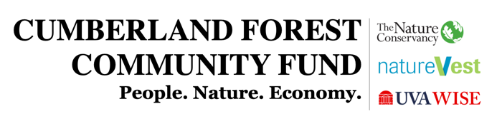

Application

- Project name
Click or tap here to enter text.

- Project location
Click or tap here to enter text.

- Applicant Organization
Click or tap here to enter text.

- FEDERAL ID NUMBER
Click or tap here to enter text.

- PROJECT LEAD AND MAIN POINT OF CONTACT (NAME, TITLE, EMAIL AND PHONE NUMBER)
Click or tap here to enter text.

- EXECUTIVE SUMMARY
Summarize the project scope and benefits in approximately 150 words or less.
Click or tap here to enter text.

- Projected START and End Dates
Should be no more than one year. Please note if there are any start/end date dependencies, e.g., if the project timeline is dependent on external funding, other approvals, etc.

Project Start Date (Month/Year):  Click or tap here to enter text. | Project End Date (Month/Year):  Click or tap here to enter text.

Dependencies (if any):
Click or tap here to enter text.

- FUNDING REQUEST
Total Amount:
Click or tap here to enter text.

- PROJECT DESCRIPTION
Detailed description that expands upon the Executive Summary. If the funding request is in support of a larger project that has other sources of funding, please provide a clear explanation for how CFCF resources will be used. Additionally, please indicate the demand for the project and include an explanation of how the project contributes to local community priorities. Limit 3 pages.
Click or tap here to enter text.

- PROJECT GOALS
Describe your overall goals for the project. How will this be transformative and help Southwest Virginia grow?
Click or tap here to enter text.

- PROJECT DELIVERABLES
What are the main outcomes for the project? How do you know if you are reaching your project goals described in the section above? Please note specific indicators of success for the project, preferably using a list format. These metrics will be reviewed to evaluate progress for the grant period.
Click or tap here to enter text.

- MILESTONES
List key dates, activities or events that will be important milestones leading to the successful completion of the project.
Click or tap here to enter text.

- PROJECT IMPACT
How will the project positively impact economic vitality and environmental quality of the coalfield counties of Southwest Virginia? How does the project generate an economic, environmental and community impact, e.g., number of annual visitors, revenue generated, jobs created, number of acres environmentally impacted, etc.?
Click or tap here to enter text.

- PROJECT TEAM CAPACITY AND ROLES
Describe your project team members’ skills and capacities, and detail the specific roles each team member will play in the execution of the project, e.g. fiscal management, implementation activities, reporting, fiscal agent (if other than applicant), etc.
Click or tap here to enter text.

- TEAM BIOS
Attach a brief professional bio for each member of the project team.

- BUDGET NARRATIVE
Attach a completed budget narrative template, listing all sources and uses by fiscal year—July 1 to June 30.) If there are additional sources of funding supporting the project (beyond CFCF funding) please make sure to explain specifically how CFCF funding will be used.

- SUSTAINABILTY PLAN
How will this program be supported and governed once CFCF funds are expended? Please be specific about future commitments.
Click or tap here to enter text.

- RISK MANAGEMENT PLAN
What is necessary for project success, other than CFCF funding? Are there dependencies on other funding sources? What could derail project success? Are there specific environmental risks that could delay or derail work on the project? What actions will be taken to mitigate key risks?
Click or tap here to enter text.

- LETTERS OF COMMITMENT AND/OR SUPPORT (OPTIONAL)
Please attach letters outlining collaboration and/or support for this project.

- MAPS, SITE PLANS, OR PERMIT DETAILS (IF APPLICABLE)
Please attach all relevant supporting documentation.

SIGNATURE

PROPOSER SIGNATURE:
Name: Date: Click or tap here to enter text.
Click or tap here to enter text.

